**The Equalizer & The Official Publication of Mabalacat City College**

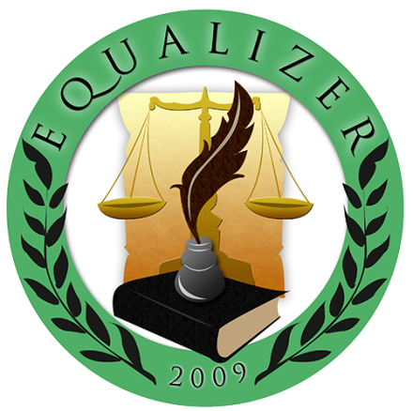

**Sprint #2**

Members:

GUNNING, IRENE L.

LAROGA, RUSSEL Z.

FRANCISCO, JULIUS D.

NICDAO, CHONNA D.

MARIN III, RUBEN F.

QUITALIG, ADRIAN F.

SANDIG, CEEJAY T.

ARCEO, SHARMAINE C.

TEAM EQUALIZER – March 16, 2017

|  |  |  |
| --- | --- | --- |
| Scrum TEAM | SPRINT NAME AND DURATION | CHANGES |
| Team Equalizer | Equalizer Sprint #2  6/Mar/17  to  16/Mar/17 | * **EQUA02- Announcement page 10 SP** * Announcements are used to inform the user about what happening in our school. The admin have an authority to Create, Read, Update and Delete. |
| Team Equalizer | Equalizer Sprint #2  6/Mar/17  to  16/Mar/17 | * **EQUA02- Article page 10 SP** * Articles are used to inform the student or the user about the latest news in our school and in the society. The admin have an authority to Create, Read, Update and Delete. |

**EQUA01- Announcement page**

Announcements are used to inform the user about what happening in our school. The admin have an authority to Create, Read, Update and Delete.

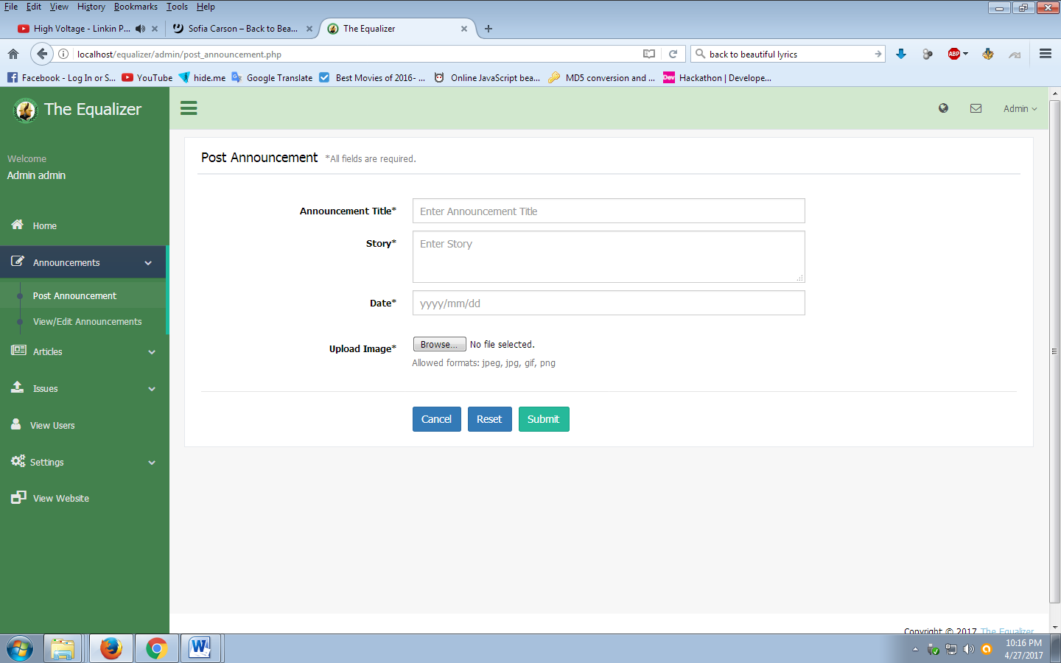

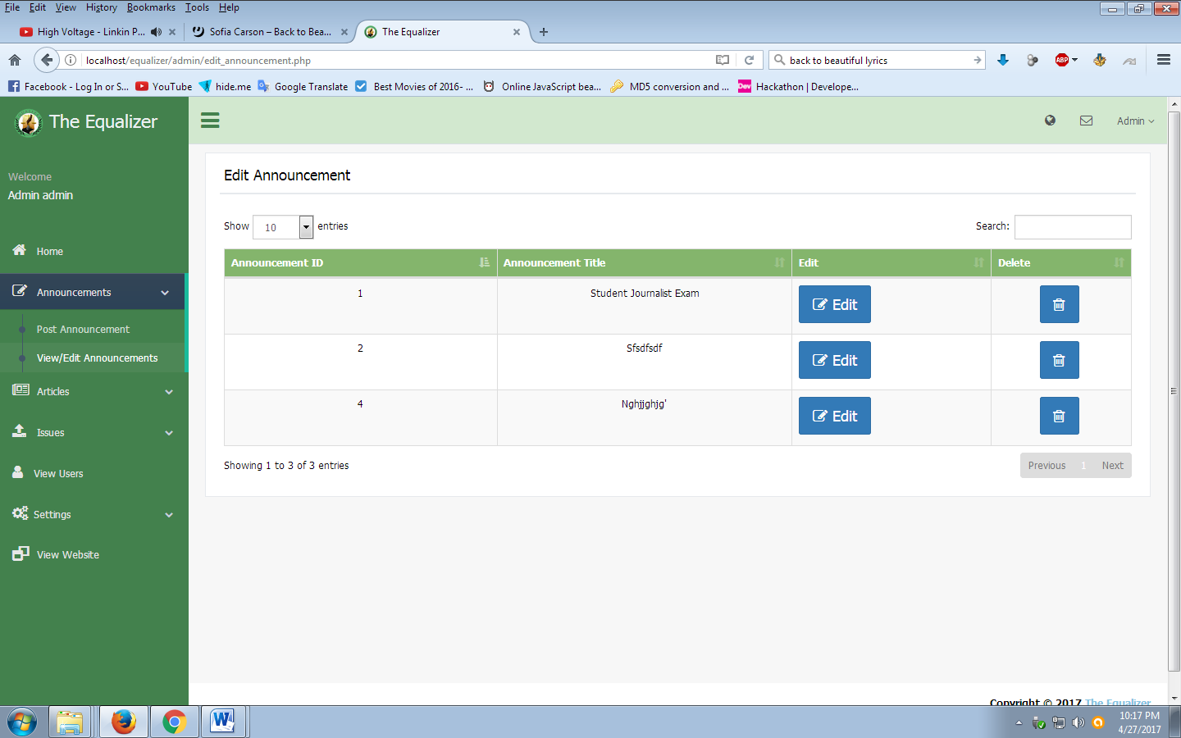

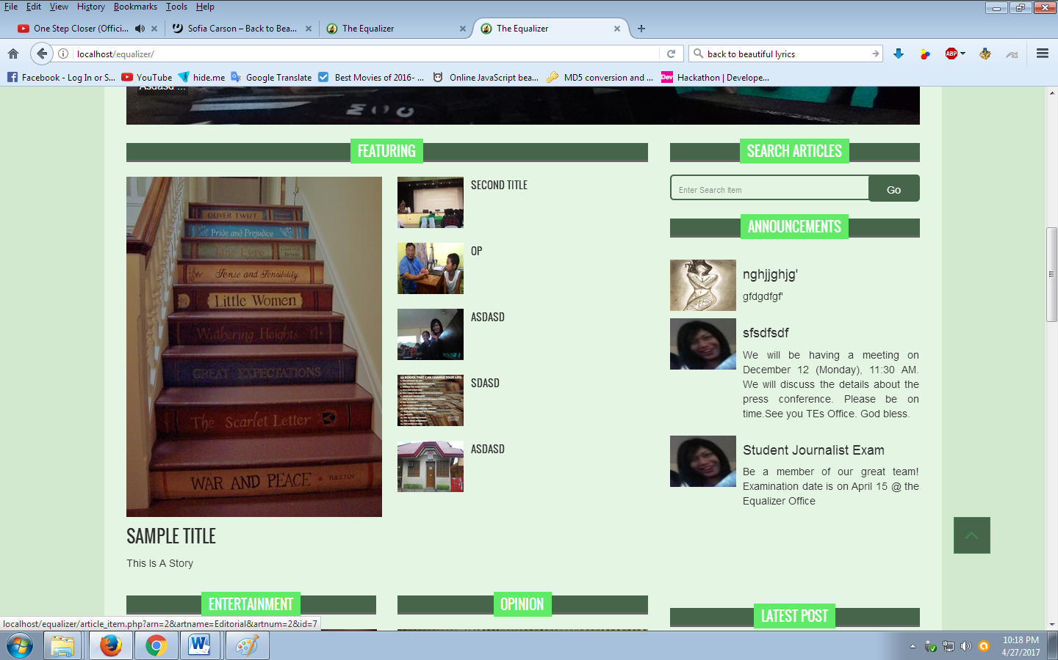

**EQUA02- Article page**

Articles are used to inform the student or the user about what latest news in our school and in the society. The admin have an authority to Create, Read, Update and Delete.

